Consensus n-Trees
T. Margush and F. R. McMorris
Bulletin of Mathematical Biology, Vol. 43, No. 2, pp. 239-244, 1981
Abstract
A method can be used to define a consensus of several trees.
- Introduction
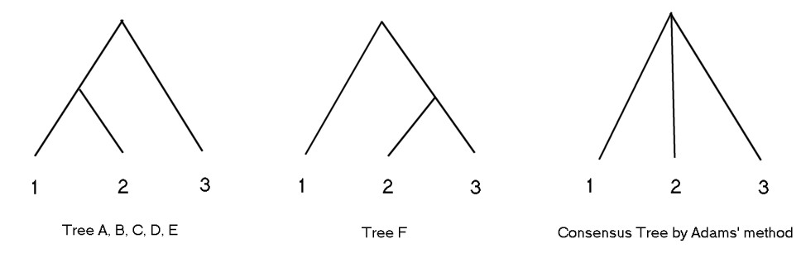

- Majority Rule Consensus
Definition 1. Let τ = {T₁,…, T_{m}} be a collection of n-trees. The majority rule of τ, denoted by M(τ), is the subset of P(S) where A ∈ M(τ) if and only if A ∈ T_{i} for more than half of the T_{i}s.

Theorem 1. If τ = {T₁,…, T_{m}} is a collection of n-trees, then M(τ) is an n-tree.

Definition 2. A median for the collection τ of n-trees is an n-tree M that minimizes ∑_{T∈τ} d(M, T).

Theorem 2. If τ is a collection of n-trees, then M(τ) is a median for τ. Furthermore, if |τ| is odd, then M(τ) is the unique median for τ.
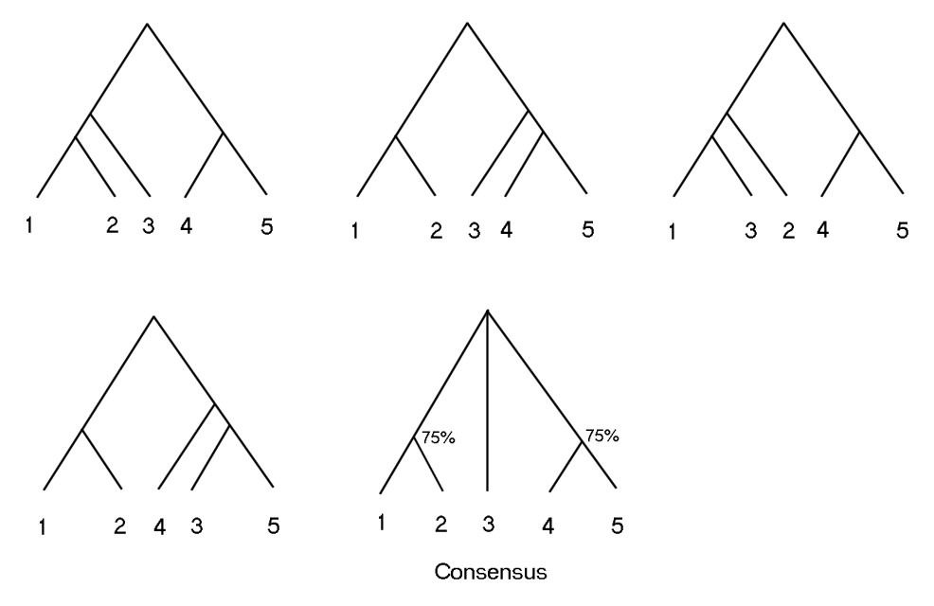

Created by : Chao-Li Peng
Date : Jan. 29, 2002

